[Insurance Company] | Re: Patient Name: __________________________
[Address Line 1] | Policy ID: __________________________
[Address Line 2] | Policy Group: __________________________
 | Date of Birth: __________________________
[Date]

Attn: [Medical/Pharmacy Director], [Department]

Re: Letter of Appeal for ONGENTYS® (opicapone) for [Plan Member Name]

Dear [Medical/Pharmacy Director]:

I am writing on behalf of [patient’s name], a [male/female] patient aged [patient’s age] years who was diagnosed with Parkinson’s disease (PD) on [date], to request reconsideration of your denial of coverage for ONGENTYS® (opicapone) capsules for the treatment of PD. Based on my experience with treating patients with PD, and the patient’s condition and medical history, I believe treatment with ONGENTYS is appropriate and medically necessary. This letter provides the clinical rationale and relevant information about the patient’s treatment.

Early in PD, levodopa gives good movement control for most of the day, but as the disease advances, all patients develop fluctuations in the control of their symptoms. Up to 40% of patients develop motor fluctuations within 4 to 6 years after starting levodopa, increasing to almost all patients 10 years from diagnosis.^{1,2}

In PD, 2 major enzymes can limit levodopa from getting to the brain: DOPA decarboxylase (DDC) & catechol-O-methyltransferase (COMT). When the DDC enzyme is inhibited by carbidopa, COMT becomes the predominant peripheral metabolic pathway for levodopa. When patients on carbidopa/levodopa experience "off" time, a common treatment approach is to increase the dose and/or frequency of carbidopa/levodopa—leaving the COMT enzyme unchecked.³⁻¹¹

ONGENTYS is a COMT inhibitor and is FDA approved as adjunctive treatment to carbidopa/levodopa in patients with PD experiencing “off” episodes. As carbidopa protects levodopa from the DDC enzyme, ONGENTYS protects levodopa from the COMT enzyme in the periphery, which may increase the ability of levodopa to reach the brain.^{6,12}

The efficacy of ONGENTYS as adjunctive treatment to carbidopa/levodopa was evaluated in two 14- to 15-week, double-blind, randomized, parallel-group studies of patients with PD experiencing "off" episodes. All patients were treated with carbidopa/levodopa (alone or in combination with other PD medications). The double-blind period for each study began with an up to 3-week carbidopa/levodopa adjustment period, followed by a stable maintenance period of 12 weeks.¹²
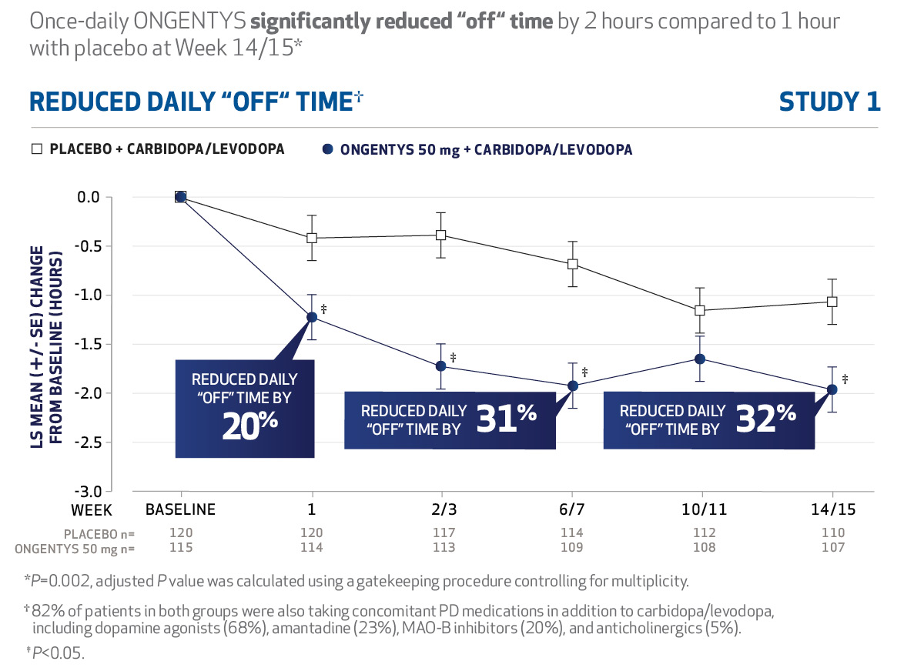

In Study 1, the intent-to-treat (ITT) population included patients treated with ONGENTYS 50 mg (n=115), placebo (n=120), or active comparator (entacapone 200 mg) (n=120). In Study 2, the ITT population included patients treated with ONGENTYS 50 mg (n=147) or placebo (n=135). ONGENTYS significantly reduced mean absolute “off” time at 14/15 weeks when compared with placebo. Similar decreases in “off” time were observed at Week 1 for patients in both Study 1 and Study 2 (-1.24 hours vs -0.42 hours for placebo, and -1.22 hours vs -0.47 hours for placebo, respectively). ONGENTYS also increased mean absolute “on” time without troublesome dyskinesia. ONGENTYS was generally well tolerated in the clinical studies.¹²⁻¹⁴

After the double-blind period, patients were able to enroll in a 1-year open-label extension of ONGENTYS. Patients who had been on placebo or active comparator in the double-blind period received ONGENTYS in the open-label period. Patients who remained on ONGENTYS from the double-blind period through the open-label extension period maintained their increases in “good on” time, and patients who switched from placebo to ONGENTYS saw a 1-hour increase in “good on” time. Patients who switched from entacapone to ONGENTYS had an increase of almost 45 minutes in additional “good on” time. No new safety concerns related to the long-term use of ONGENTYS were observed in this study.^{13,15}

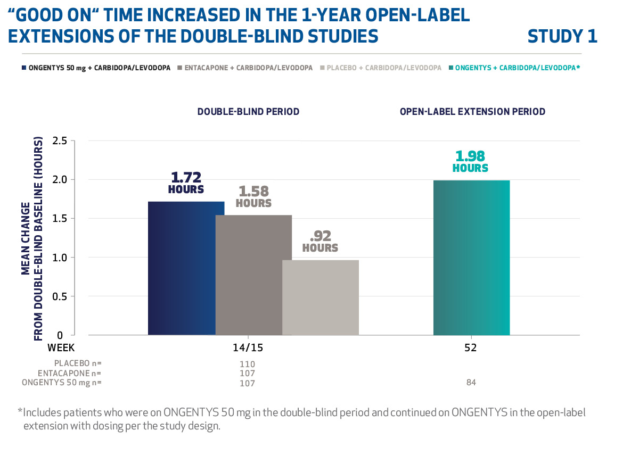
A copy of the [level of denial] denial letter is included along with medical notes in response to the denial. Considering the patient’s history and condition, I believe treatment with ONGENTYS is medically necessary for my patient.

Please contact my office at [office phone number] if any additional information is required to ensure prompt approval for this course of treatment.

Thank you for your time and immediate attention to this request.

Sincerely,

[Physician’s name]

[Reminder to list enclosures as appropriate or requested by the plan in the denial letter (eg, excerpt(s) from patient’s medical record, relevant treatment guidelines, and product Prescribing Information).]
FDA=US Food and Drug Administration; LS=least squares; MAO-B=monoamine oxidase-B; SE=standard error.

References: 1. Chou KL, Stacy M, Simuni T, et al. The spectrum of “off” in Parkinson’s disease: what have we learned over 40 years? Parkinsonism Relat Disord. 2018;51:9-16. 2. Stocchi F, Antonini A, Barone P, et al. Early DEtection of wEaring off in Parkinson disease: the DEEP study. Parkinsonism Relat Disord. 2014;20(2):204-211. 3. Tambasco N, Romoli M, Calabresi P. Levodopa in Parkinson’s disease: current status and future developments. Curr Neuropharmacol. 2018;16(8):1239-1252. 4. Männistö PT, Kaakkola S. Catechol-O-methyltransferase (COMT): biochemistry, molecular biology, pharmacology, and clinical efficacy of the new selective COMT inhibitors. Pharmacol Rev. 1999;51(4):593-628. 5. Connolly BS, Lang AE. Pharmacological treatment of Parkinson disease: a review. JAMA. 2014;311(16):1670-1683. 6. LeWitt PA. Levodopa for the treatment of Parkinson’s disease. N Engl J Med. 2008;359(23):2468-2476. 7. Reilly DK, Rivera-Calimlim L, Van Dyke D. Catechol-O-methyltransferase activity: a determinant of levodopa response. Clin Pharmacol Ther. 1980;28(2):278-286. 8. Andersson I, Granerus AK, Jagenburg R, Svanborg A. Intestinal decarboxylation of orally administered L-dopa: influence of pharmacological preparation, dose magnitude, dose sequence and food intake. Acta Med Scand. 1975;198(5):415-420. 9. Fabbri M, Rosa MM, Ferreira JJ. Adjunctive therapies in Parkinson’s disease: how to choose the best treatment strategy approach. Drugs Aging. 2018;35(12):1041-1054. 10. Ondo WG. Motor complications in Parkinson’s disease. Int J Neurosci. 2011;121(suppl 2):37-44. 11. Olanow CW, Stern MB, Sethi K. The scientific and clinical basis for the treatment of Parkinson disease (2009). Neurology. 2009;72(21)(suppl 4):S1-S136. 12. ONGENTYS [package insert]. Bridgewater, NJ: Amneal Pharmaceuticals LLC; 2023. 13. Data on file. Amneal Pharmaceuticals LLC. 14. Ferreira JJ, Lees A, Rocha JF, et al. Opicapone as an adjunct to levodopa in patients with Parkinson’s disease and end-of-dose motor fluctuations: a randomised, double-blind, controlled trial. Lancet Neurol. Published December 22, 2015. doi:10.1016/S1474-4422(15)00336-1 15. Ferreira JJ, Lees AJ, Poewe W, et al. Effectiveness of opicapone and switching from entacapone in fluctuating Parkinson disease. Neurology. 2018;90(21):e1849-e1857.

© 2024 Amneal Specialty, a division of Amneal Pharmaceuticals LLC. All rights reserved.
This letter and the information contained herein are intended for use by U.S. residents only.
Amneal Pharmaceuticals’ rights to promote, offer for sale, and sell ONGENTYS are limited
to the U.S.
ONGENTYS® is a registered trademark of BIAL - Portela & Cª., S.A.
PP-ADW-ONG-US-0007 02/2024
Under license from

